Visit the Wisconsin Rapids Culver’s Monday May 22, 2017 to help raise money for the Never Forgotten Honor Flight.
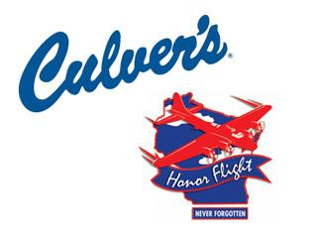
We will donate 10% of sales to help fly our Heroes to Washington D.C. to visit their Memorials.