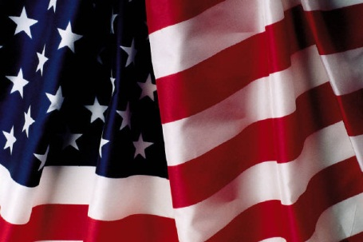
Never Forgotten Honor Flight Committee and Volunteers:
I would like to take this opportunity on behalf of my family to thank you for all you do to make the Never Forgotten Honor Flight such a memorable experience not only for our Veterans but for their guardians and families as well.
I had the privilege of traveling on the October 22, 2012 flight as a guardian for my father, a WWII Veteran and another local gentleman, a Korean War Veteran. The day was filled with great conversation with many of the veterans regarding their experiences during the time of war. Their stories and the Veterans themselves will remain with me forever.
The welcome we received once we arrived in Washington was truly emotional and set the tone for the entire day and evening. It was inspirational watching Mail Call on our return flight and the welcome home that the veterans received was indescribable.
Thank you for the endless hours that you give to make sure that everything flows smoothly. From the preflight dinner to the flight home you have done an incredible job!!
Thank you again for helping to make this trip a possibility.
Judy Heil

